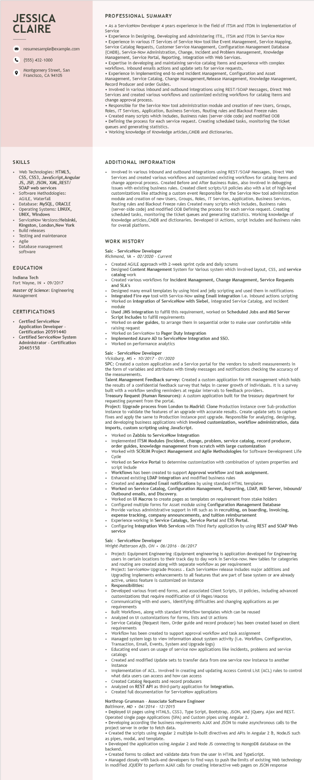
JESSICA CLAIRE
9
resumesample@example.com
(555) 432-1000
Montgomery Street, San Francisco, CA 94105
PROFESSIONAL SUMMARY
• As a ServiceNow Developer 4 years experience in the field of ITSM and ITOM in implementation of Service
• Experience in Designing, Developing and Administering ITIL, ITSM and ITOM in Service Now Experience in various IT Services of Service Now tool like Event Management, Service Mapping, Service Catalog Requests, Customer Service Management, Configuration Management Database (CMDB), Service-Now Administration, Change, Incident and Problem Management, Knowledge Management, Service Portal, Reporting, Integration with Web Services.
• Expertise in developing and maintaining service catalog items and experience with complex workflows. Inbound emails actions and update sets for service requests.
• Experience in implementing end-to-end Incident Management, Configuration and Asset Management, Service Catalog, Change Management, Release Management, Knowledge Management, Record Producer and order Guides.
. Involved in various inbound and outbound integrations using REST/SOAP Messages, Direct Web Services and I created various workflows and customized existing workflows for catalog items and change approval process.
• Responsible for the Service Now tool administration module and creation of new Users, Groups, Roles, IT Services, Application, Business Services, Routing rules and Blackout Freeze rules
• Created many scripts which includes, Business rules (server-side code) and modified OOB
• Defining the process for each service request. Creating scheduled tasks, monitoring the ticket queues and generating statistics.
• Working knowledge of Knowledge articles, CMDB and dictionaries.
SKILLS
Web Technologies: HTML5,
CSS, CSS3, JavaScript, Angular JS, JSP, JSON, XML, REST/ SOAP web services Software Methodologies: AGILE, Waterfall Database: MySQL, ORACLE Operating Systems: LINUX, UNIX, Windows ServiceNow Versions:Helsinki, Kingston, London, New York Build releases
Testing and maintenance
Agile
Database management
software
EDUCATION
Indiana Tech
Fort Wayne, IN⚫ 09/2017
Master of Science: Engineering Management
CERTIFICATIONS
Certfied ServiceNow
Application Developer -
Certification 20591440
.
Certified ServiceNow System
Administrator - Certification 20465158
ADDITIONAL INFORMATION
Involved in various inbound and outbound integrations using REST/SOAP Messages, Direct Web Services and created various workflows and customized existing workflows for catalog items and change approval process. Created Before and After Business Rules, also involved in debugging issues with existing business rules. Created client scripts/Ul policies also with a lot of high-level customizations like attaching a custom event Responsible for the Service Now tool administration module and creation of new Users, Groups, Roles, IT Services, Application, Business Services, Routing rules and Blackout Freeze rules Created many scripts which includes, Business rules (server-side code) and modified OOB Defining the process for each service request. Creating scheduled tasks, monitoring the ticket queues and generating statistics. Working knowledge of Knowledge articles, CMDB and dictionaries. Developed UI Actions, script includes and Business rules for overall platform.
WORK HISTORY
Saic ServiceNow Developer
Richmond, VA 02/2020 - Current
Created AGILE approach with 2-week sprint cycle and daily scrums
Designed Content Management System for Various system which involved layout, CSS, and service catalog work
Created various workflows for Incident Management, Change Management, Service Requests and SLA's
Designed many email templates by using html and jelly scripting and used them in notifications Integrated Fire eye tool with Service-Now using Email integration i.e. inbound actions scripting Worked on integration of ServiceNow with Siebel, integrated Service Catalog, and Incident
module
Used
I JMS integration to fulfill this requirement, worked on Scheduled Jobs and Mid Server Script Includes to fulfill requirements
Worked on order guides, to arrange them in sequential order to make user comfortable while raising request
Worked on ServiceNow to Pager Duty Integration
• Implemented Azure AD to ServiceNow Integration and SSO.
• Worked on performance analytics
Saic ServiceNow Developer
Vicksburg, MS. 10/2017 - 01/2020
SPC: Created a custom application and a Service portal for the vendors to submit measurements in the form of f variables and attributes with timely messages and notifications checking the accuracy of the measurements.
Talent Management Feedback survey: Created a custom application for HR management which holds the results of a confidential feedback survey that helps in career growth of individuals. It is a survey built with a workflow sending reminders at regular intervals to feedback providers. Treasury Request (Human Resources): A custom application built for the treasury department for requesting payment from the portal.
Project: Upgrade process from London to Madrid: Clone Production instance over Sub-production instance to validate the features of an upgrade with accurate results. Create update sets to capture fixes and apply the same to Production instance post upgrade. Responsible for analyzing, designing, and developing business applications which involved customization, workflow administration, data imports, custom scripting using JavaScript.
.
Worked on Zabbix to ServiceNow Integration
Implemented ITSM Modules (Incident, change, problem, service catalog, record producer, order guides, knowledge management from scratch with large customization
Worked with SCRUM Project Management and Agile Methodologies for Software Development Life Cycle
Worked on Service Portal to determine customization with combination of system properties and script include
Workflows has been created to support Approval workflow and task assignment.
• Enhanced existing LDAP integration and modified business rules
Created and automated Email notifications by using standard HTML templates
Worked on Service Catalog, Configuration Management, Reporting, LDAP, MID Server, Inbound/ Outbound emails, and Discovery.
Worked on UI Macros to create pages as templates on requirement from stake holders
Configured multiple forms for Asset module using Configuration Management Database
Provide various administrative support in HR such as in recruiting, on boarding, invoicing,
expense tracking, company announcements, and tuition reimbursement Experience working in Service Catalogs, Service Portal and ESS Portal.
Configuring Integration Web Services with Third Party application by using REST and SOAP Web service
Saic ServiceNow Developer
Wright-Patterson Afb, OH 06/2016 - 06/2017
• Project: Equipment Engineering : Equipment engineering is application developed for Engineering users in certain locations to their track day to day work in Service-now. New tables for categories and routing are created along with separate workflow as per requirement
Project: ServiceNow Upgrade Process. Each ServiceNow release includes major additions and Upgrading implements enhancements to all features that are part of base system or are already active, unless feature is customized on instance
Responsibilities:
Developed various front-end forms, and associated Client Scripts, UI policies, including advanced customizations that require modification of UI Pages/Macros
Communicating with end users, identifying difficulties and changing applications as per requirements
Built Workflows, along with standard Workflow templates which can be reused
Analyzed on UI customizations for forms, lists and UI actions
Service Catalog (Request Item, Order guide and record producer) has been created based on client requirements
Workflow has been created to support approval workflow and task assignment
Managed system logs to view information about system activity (i.e. Workflow, Configuration, Transaction, Email, Events, System and Upgrade logs)
Educating end users on usage of service now applications like incidents, problems and service catalogs catalogs
Created and modified Update sets to transfer data from one service now instance to another
instance instance
Implementation of ACL. Involved in creating and updating Access Control List (ACL) rules to control what data users can access and how can access
Created Catalog Requests and record producers
Analyzed on REST API as third-party application for Integration.
Created full documentation for ServiceNow applications
Northrop Grumman - Associate Software Engineer
Baltimore, MD 04/2014 - 12/2015
• Deployed UI pages using HTML5, CSS3, Type Script, Bootstrap, JSON, and jQuery, Ajax and REST. Operated single page Applications (SPA) and Custom pipes using Angular 2.
• Developing according the business requirements AJAX and JSON to make asynchronous calls to the project server in order to fetch data.
• Created the scripts using Angular 2 multiple in-built directives and APIs in Angular 2 &, NodeJS such as pipes, modal, and template.
• Developed the application using Angular 2 and Node JS connecting to MongoDB database on the backend.
• Created forms to collect and validate data from the user in HTML and TypeScript.
• Managed closely with back-end developers to find ways to push the limits of existing Web technology
in modified JQUERY to perform AJAX calls for creating interactive web pages on JSON response

